ABOUT THE UNIVERSITY PAGE AND THE MATERIALS REQUIRED FOR CONTENT
To see what a university page looks like, click here: https://bit.ly/3cM68Ht
Each participating university from your country will get a dedicated page on the website. Access to each dedicated university page will be from your country page.
I. Carousel:
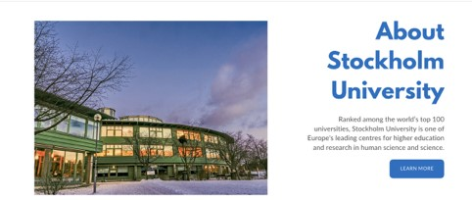
- An image carousel appears at the top of the university page https://bit.ly/3cM68Ht

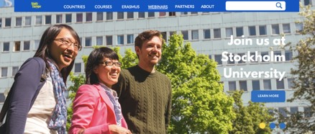
- Universities can use the carousel to promote a course, a programme or an activity. Each university will be able to decide for themselves what they want to promote and what image they wish to upload onto the carousel.
- Universities can upload between three to five images on the carousel.
- We will provide easy-to-use instructions to university representatives for them to upload their carousel images.
II. About the University:
- There is a write-up about the university accompanied by a key image of the university https://bit.ly/3cM68Ht
- We will need a write-up about each university.
III. Programmes:
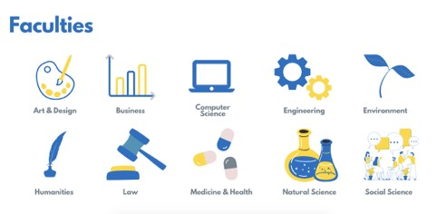
- This is the section featuring the various programmes such as Bachelor, Masters, Phd. What goes into this section depends on what the university is able to offer the international student https://bit.ly/3cM68Ht
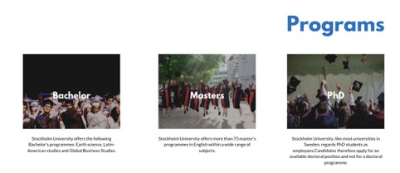
- We will require a write-up about each programme from the respective universities. A link to their university page will be included in the write-up. Visitors from the SIE site will be able to click and seamlessly visit the respective university sites.
IV. Faculties:
- This section features the university’s faculties that are relevant to international students.
- Clicking on the faculty favicon will take website visitors to the corresponding faculty pages on the university’s website (each favicon is linked to faculty page of the university).
V. University video:
• A short video showing the university campus and facilities. The university should provide us with a Youtube link to the video which will be embedded into the website https://bit.ly/3cM68Ht
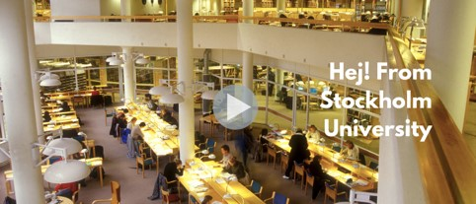
VI. Virtual tour:
• This will be a virtual tour of the campus. The university should provide us with a panoramic image of university or google map link of university https://bit.ly/3cM68Ht
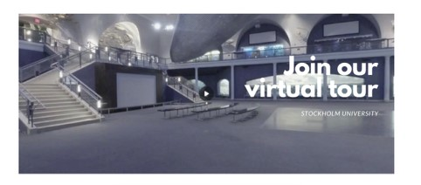
VII. Global alumni community:
- This section features testimonials from the university’s alumni community.
- We will require a minimum of 4 testimonials from the university’s alumni.

